Allotment Newsletter
Summer 2026
East Finchley Allotment Holders Association

Our AGM this year was blessed with sunshine and a wonderful group of allotment members who are committed to playing their part in maintaining and developing the site.

We are now in the fortunate position of having a fully functioning committee who give their time and effort to endure that our site is maintained and developed:

Deborah Isaacs Chair , Bank Trustee and Tree Policy
Christine Goodfellow – Secretary
Tina Courtney-Thompson - New Lettings
Sue Chantrell Treasurer and Bank Trustee
Claudia Farabegoli Cherin - Site manager
Liz Hanchet - Trading Shed manager
Pat Flinter - Site management
David Holt - Site management, Bank trustee
Liz Cooke Szewczyk - Fence with Fuel Lands
Maxine Klein - Newsletter
Sean Cassidy - Pipes, water, site management
John Kyriakides -
Simon Williams - Conservation
Masami Yokoyama - Website

Tree Policy Changes

Following concerns about too many trees being planted on cultivation plots and existing trees being allowed to grow too tall and overshadowing neighbouring plots, the Annual General Meeting on 7th June agreed to the following additions to the Bylaws
Tenants are not permitted to convert their cultivation plots into orchard plots by planting lots of saplings.

New trees and current saplings/young trees should not be permitted to exceed 3 metres in height. Excepting designated Orchard Plots, no more than 10 trees on full plots or 5 trees on half plots are permitted.

You can keep well-kept mature trees, even if they do not comply with the new bylaws. However, if you have an excess of recently planted trees, you may be asked to remove them. You may retain mature tall productive trees at their current height, but you should try to reduce this below 5m and restrict growth to 3m.

New saplings should be on dwarfing root stock. These are much easier to manage.

If you need help to prune trees or remove them, please let us know.
We hope to hold another pruning workshop later in the year, focusing this time on plums, cherries and other trees that need pruning shortly after fruiting.

Inspections

The first round of inspections this year is almost complete. It has been great to see so much wonderful production underway. If you need to make improvements to your plot, you may have received letters already or will do so shortly.

Two issues have stood out:
- Many paths are in a poor state: some are overgrown with long grass, shrubs and fruit bushes blocking them or they are lumpy and bumpy and difficult to walk along. Many peter out towards the back of plots. You are responsible for both the paths alongside your plots, together with your neighbours. Please ensure they are navigable.

- Carex Pendula clumps: this ‘elephant grass’ looks elegant in borders but is a terrible spreader and forms huge intractable clumps. Please remove it if you have any, and if that is too difficult, remove the seed heads before they develop.
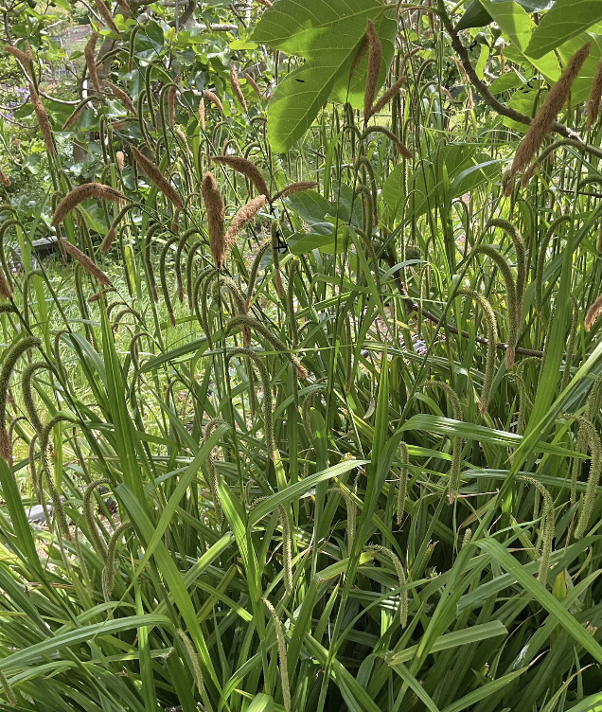
Volunteers needed
This site is entirely run by volunteers – there a huge number of jobs large and small which need to be done to keep the place running smoothly.
We are currently looking for people to do the following:
Help out with events – there will be an Autumn Festival on Sunday September 6th
Do odd DIY jobs. Many thanks to Pat for replacing the toilet door.
There is a raised path that needs mending, which the tenant can’t manage herself. Can you help?
Join a working party to clear overgrown plots (we will let you know a date two when these are fixed)
Help with the water quality testing by joining one of Ben’s monthly sessions (see below). Help out with our trees survey and organise a pruning .
If you are new to the allotment and want to get to know others joining a working party for a specific project is a great way to meet others .
Deborah Isaacs

The Allotment Mangelwurzel contest

The allotment mangelwurzel contest has begun with all free seeds passed out and the rules explained to tenants. The winner who has grown the largest and the ugliest will be determined in the autumn by 3 judges. This is a forgotten heirloom vegetable halfway between a sugar beet and beetroot which some say looks like Harry Potter's mandrakes. It is delicious mashed, roasted or pickled and is sweeter and less earthy than a beetroot. It can sit for a long time in the garden and provide abundant greens. The contest is well underway and pictured is a plant on site "finding its roots" and heading towards splendid growth with confidence.



Mary Poulter

One Year On: From Overgrown Plot to Productive Allotment

When I took on Plot C41B a year ago, I had never grown fruit or vegetables before. The plot was overgrown, cluttered and, if I’m honest, slightly intimidating.
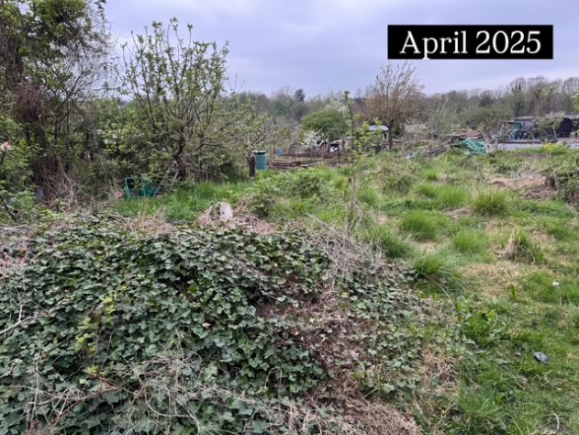
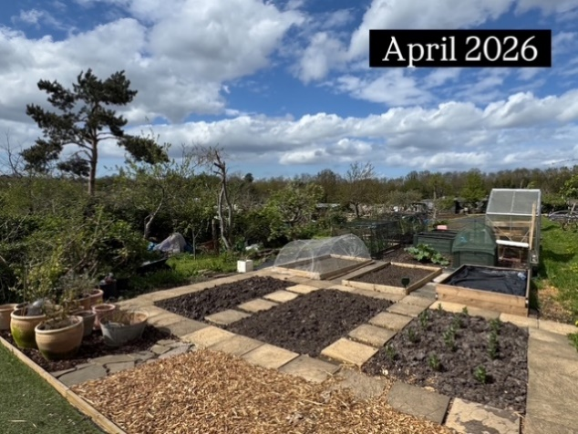

Fast forward twelve months and it has been completely transformed. What was once a neglected patch of land is now producing potatoes, onions, garlic, tomatoes, courgettes, pumpkins and sweetcorn. I’ve built a wildlife pond, added a small greenhouse and spent countless evenings and weekends learning through trial and error.

Of course, not everything has gone to plan. Birds helped themselves to the strawberries, onions bolted, aphids found their way into the greenhouse and bind weed remains a constant battle. But those setbacks have become part of the enjoyment. Every success feels earned and every failure teaches a lesson.

The biggest surprise has been how much satisfaction comes from the process itself. Watching seeds become plants, seeing wildlife arrive in the pond and gradually improving the plot has been just as rewarding as harvesting the produce.

Looking back at photographs from a year ago, it’s hard to believe it’s the same plot. There’s still plenty to learn and plenty more things to do, but what started as an overgrown challenge has become one of the most enjoyable parts of my week.

Adam - C41B

Water Quality on the allotment

For over a year, the Bounds Green Rangers have been monitoring ammonia and phosphate levels in the two streams that run through the allotments, building the evidence that something is badly wrong with the water quality.
"East Finchley Allotments is a vital green space for many local people in North London, and yet the two streams that flow through it are heavily polluted by untreated human waste released from nearby homes. For decades, Thames Water, which has the power to investigate which buildings the waste is coming from, and Barnet Council, which can enforce change, have failed to tackle the problem. We must hold both to account — this failure of coordination is a London-wide problem that destroys biodiversity and harms community wellbeing. We deserve clean rivers."
The catchment area is small — a number of properties around Creighton Avenue and the county streets — and the drains there are only meant to carry rainwater runoff into the streams. In a few cases, though, waste water from washing machines or sewage outlets has been misconnected to them instead.
It is this steady evidence, together with persistent lobbying, that has turned things around. The allotments went from being overlooked to ranking among Thames Water's top [10/50] funded projects nationally, with a survey now under way to identify the properties responsible.
Sessions are half an hour each. Dates and times are as follows:
• Tuesday 16th June – 18:00
• Tuesday 21st July – 18:00
• Tuesday 18th August – 18:00
• Tuesday 15th September – 18:00
Meet at: The Community Shed
Ben Nathan
Contact: boundsgreenrangers@gmail.com
Have you seen any of these little critters on your apple trees?
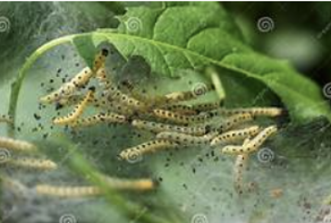

They may be encased in silk webs designed to protect them from birds. They are Apple Ermine Moth Caterpillars. A number have been spotted on the allotments this year.
They probably won’t seriously damage mature apple trees, the leaves usually grow back later in the season, but young trees may be damaged badly and older trees may be weakened
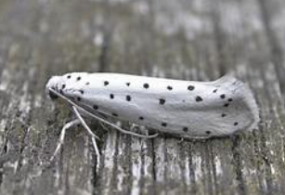
This is the adult moth – white with black spots.
It is a bit late to treat them this year, but here is some advice for next season.
1, Pick them off by hand (whilst wearing gloves). Bag and bin everything — do not compost (caterpillars survive).
2. Hose them off with a strong jet of water. Pick them up and clear, because they can climb back up again.
3. There are commercially available biological controls and pheromone traps, best used in April-May when they are feeding.
4. The eggs can survive on bark over winter, so if you are pruning trees which were badly infected, burn or bin prunings.
Chemical treatments exist, but should be avoided if possible. Here's hoping for a good apple harvest this year.
Deborah Isaacs
Shed News : Summer 2026
----- ALL COMPOSTS NOW £6
Finchley Nurseries Multipurpose with added peat 40L
Westland Peat free Multipurpose with added John Innes 50L
Westland Peat Free Organic Gold Multipurpose 46L
Westland Peat Free Ericaceous
John Innes No 1 (seed) 28L
John Innes No 2 (potting on) 28L
Westland Farm Manure 50L £5
Seeds to sow this Autumn
Aquadulce Broad Bean seeds for planting in October.
Autumn King Carrots and Radish French Breakfast can still be sown in July.
Green Manures to cover the soil when the bed is empty and to fix nitrogen: We stock Field Beans and Phacelia.
Unfortunately, we’re still unable to accept payment by card, so please continue to bring cheques or cash to pay for goods – and some small change is always useful.
If there's anything you would like us to stock next year, please tell the volunteer on shed duty and we'll try to get it for you.
Summer opening dates:
Weekly opening will be as normal 11-1pm until the end of July. From 2nd August, due to much lower demand in late summer, the Trading Shed will be open for ONE HOUR only from 12 o’clock to 1 o’clock (times might change depending on who is on duty).
2nd August – 12-1,
9th Augus 12-1,
16 August 12-1,
23rd August - 12-1,
30th August – 12-1,
6th September – 12-1,
12th September – 12-1.

