Tree Policy Changes  Following concerns about too many trees being planted on cultivation plots and existing trees being allowed to grow too tall and overshadowing neighbouring plots, the Annual General Meeting on 7th June agreed to the following additions to the Bylaws  ---------------------------------------------------  Tenants are not permitted to convert their cultivation plots into orchard plots by planting lots of saplings.  New trees and current saplings/young trees should not be permitted to exceed 3 metres in height. Excepting designated Orchard Plots, no more than 10 trees on full plots or 5 trees on half plots are permitted.  ---------------------------------------------------  You can keep well-kept mature trees, even if they do not comply with the new bylaws. However, if you have an excess of recently planted trees, you may be asked to remove them. You may retain mature tall productive trees at their current height, but you should try to reduce this below 5m and restrict growth to 3m.  New saplings should be on dwarfing root stock. These are much easier to manage.  ---------------------------------------------------  If you need help to prune trees or remove them, please let us know.  We hope to hold another pruning workshop later in the year, focusing this time on plums, cherries and other trees that need pruning shortly after fruiting.  Deborah  # |  | Inspections  The first round of inspections this year is almost complete. It has been great to see so much wonderful production underway. If you need to make improvements to your plot, you may have received letters already or will do so shortly.  Two issues have stood out:  - Many paths are in a poor state: some are overgrown with long grass, shrubs and fruit bushes blocking them or they are lumpy and bumpy and difficult to walk along. Many peter out towards the back of plots. You are responsible for both the paths alongside your plots, together with your neighbours. Please ensure they are navigable.  - Carex Pendula clumps: this ‘elephant grass’ looks elegant in borders but is a terrible spreader and forms huge intractable clumps. Please remove it if you have any, and if that is too difficult, remove the seed heads before they develop.  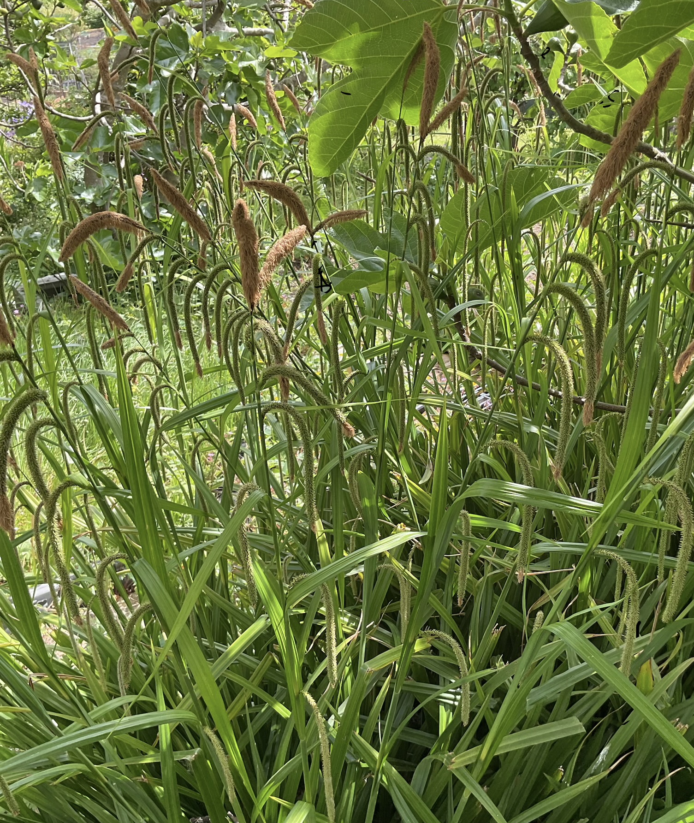
Volunteers

This site is entirely run by volunteers – there a huge number of jobs large and small which need to be done to keep the place running smoothly.

We are currently looking for people to do the following:
- Help our with events – there will be an Autumn Festival on Sunday September 6th
- Do odd DIY jobs. Many thanks to Pat for replacing the toilet door.

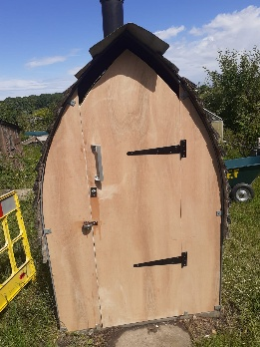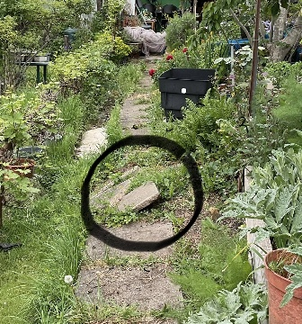

- There is a raised path that needs mending, which the tenant can’t manage herself. Can you help?
- Join a working party to clear overgrown plots (We will let you know a date two when these are fixed.)
- Help with the water quality testing by joining one of Ben’s monthly sessions
- Help out with our trees survey and organise a pruning workshop

Email expressions of interest to efallotments@gmail.com headed ‘Volunteer’ and tell us what you might be able to do. This is a great way to meet your neighbours.

Please help run this place and build up this lovely community.

